Cochrane Library

Requirements
- Maven
- Java 11

How to run application
- mvn clean install
- mvn compile exec:java -Dexec.mainClass=org.sam.vantage.labs.interview.Main

Application Design

Topics
- The web crawler first navigates to https://www.cochranelibrary.com/cdsr/reviews/topics
- The crawler then consumes the name and link of each topic in the list and parses this data into a TopicDTO

Reviews
- The web crawler is provided the list of topics discussed in the previous section
- Next, the crawler navigates to the link for each topic and parses each review on the page into a ReviewDTO
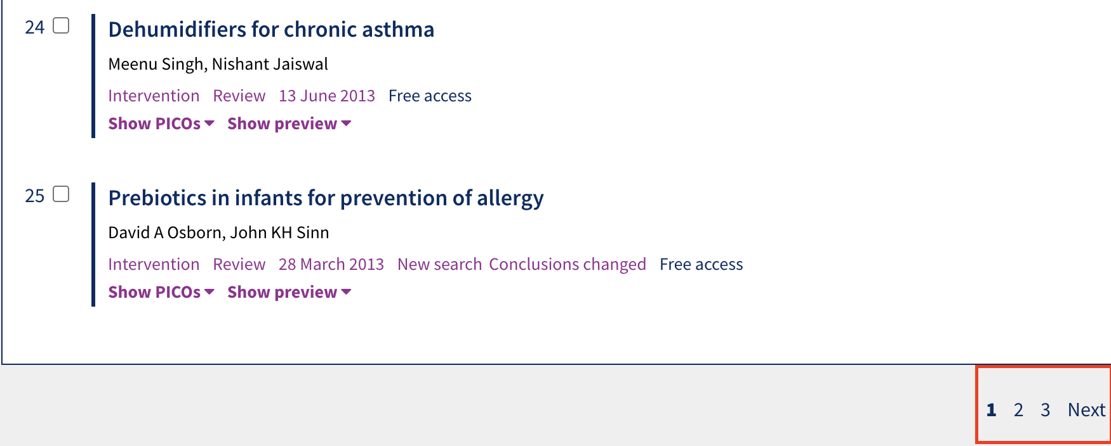
- When the full page has been parsed, the crawler consumes the link from the next page element and continues to the next page until the next page does not exist
- When all pages for a topic have been parsed, the crawler proceeds to the next topic and repeats the process

